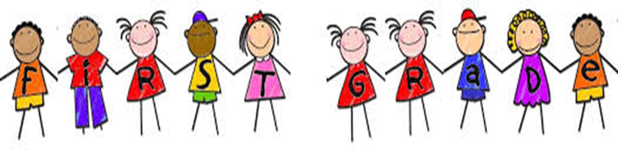

**First Grade**

**Schedule 2019 - 2020**

|  |  |
| --- | --- |
| 8:50 - 9:10 | Arrival, Calendar & Class Meeting |
| 9:15 - 10:15 | Writer’s Workshop |
| 10:15 - 11:10 | Specials (P.E., Music, Art, Library) |
| 11:20 - 12:20 | Reader’s Workshop |
| 12:20 - 12:35 | Shared Reading |
| 12:40 - 1:15 | Recess & Lunch |
| 1:20 - 2:20 | Math Workshop |
| 2:20 - 2:35 | 1st Grade Earned Recess |
| 2:40 - 3:00 | Phonics & Word Work |
| 3:00 - 3:45 | Science & Social Studies |
| 3:45 - 3:55 | Clean Up, Pack Up & Stack Up |
| 3:55 - 4:05 | Dismissal |